Electronic Supplementary Information

Donor-substituted cyanoethynylethenes: powerful chromophores for opto-electronic applications

Nicolle N. P. Moonenª, Robin Gistª, Corinne Boudon^{b}, Jean-Paul Gisselbrecht^{b}, Paul Seilerª, Tsuyoshi Kawai^{c}, Atsushi Kishioka^{c}, Maurice Gross^{b}, Masahiro Irie^{c} and François Diederich*^{,a}

ªLaboratorium für Organische Chemie, ETH-Hönggerberg, HCI, CH-8093 Zürich, Switzerland. Email: diederich@org.chem.ethz.ch
^{b}Laboratoire d’Electrochimie et de Chimie Physique du Corps Solide, UMR 7512, C.N.R.S., Université Louis Pasteur, 4, rue Blaise Pascal, F-67000 Strasbourg, France
^{c}Department of Chemistry and Biochemistry, Graduate School of Engineering, Kyushu University, Hakozaki 6-10-1, Higashiku, Fukuoka 812-8581, Japan

Electronic Supplementary Information

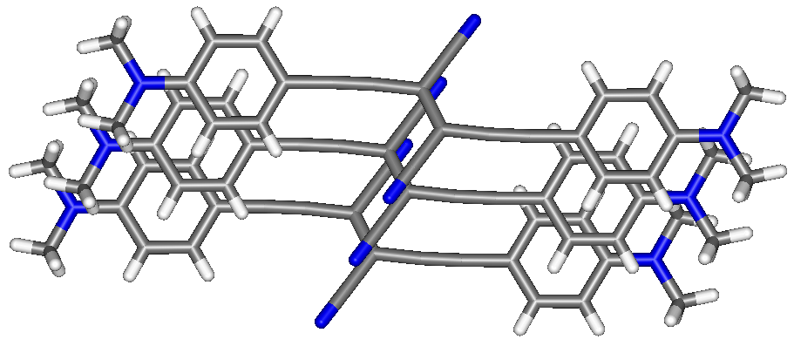

Fig. 1 Crystal packing of 5, showing the slipped parallel stacking of the phenyl rings.
Electronic Supplementary Information
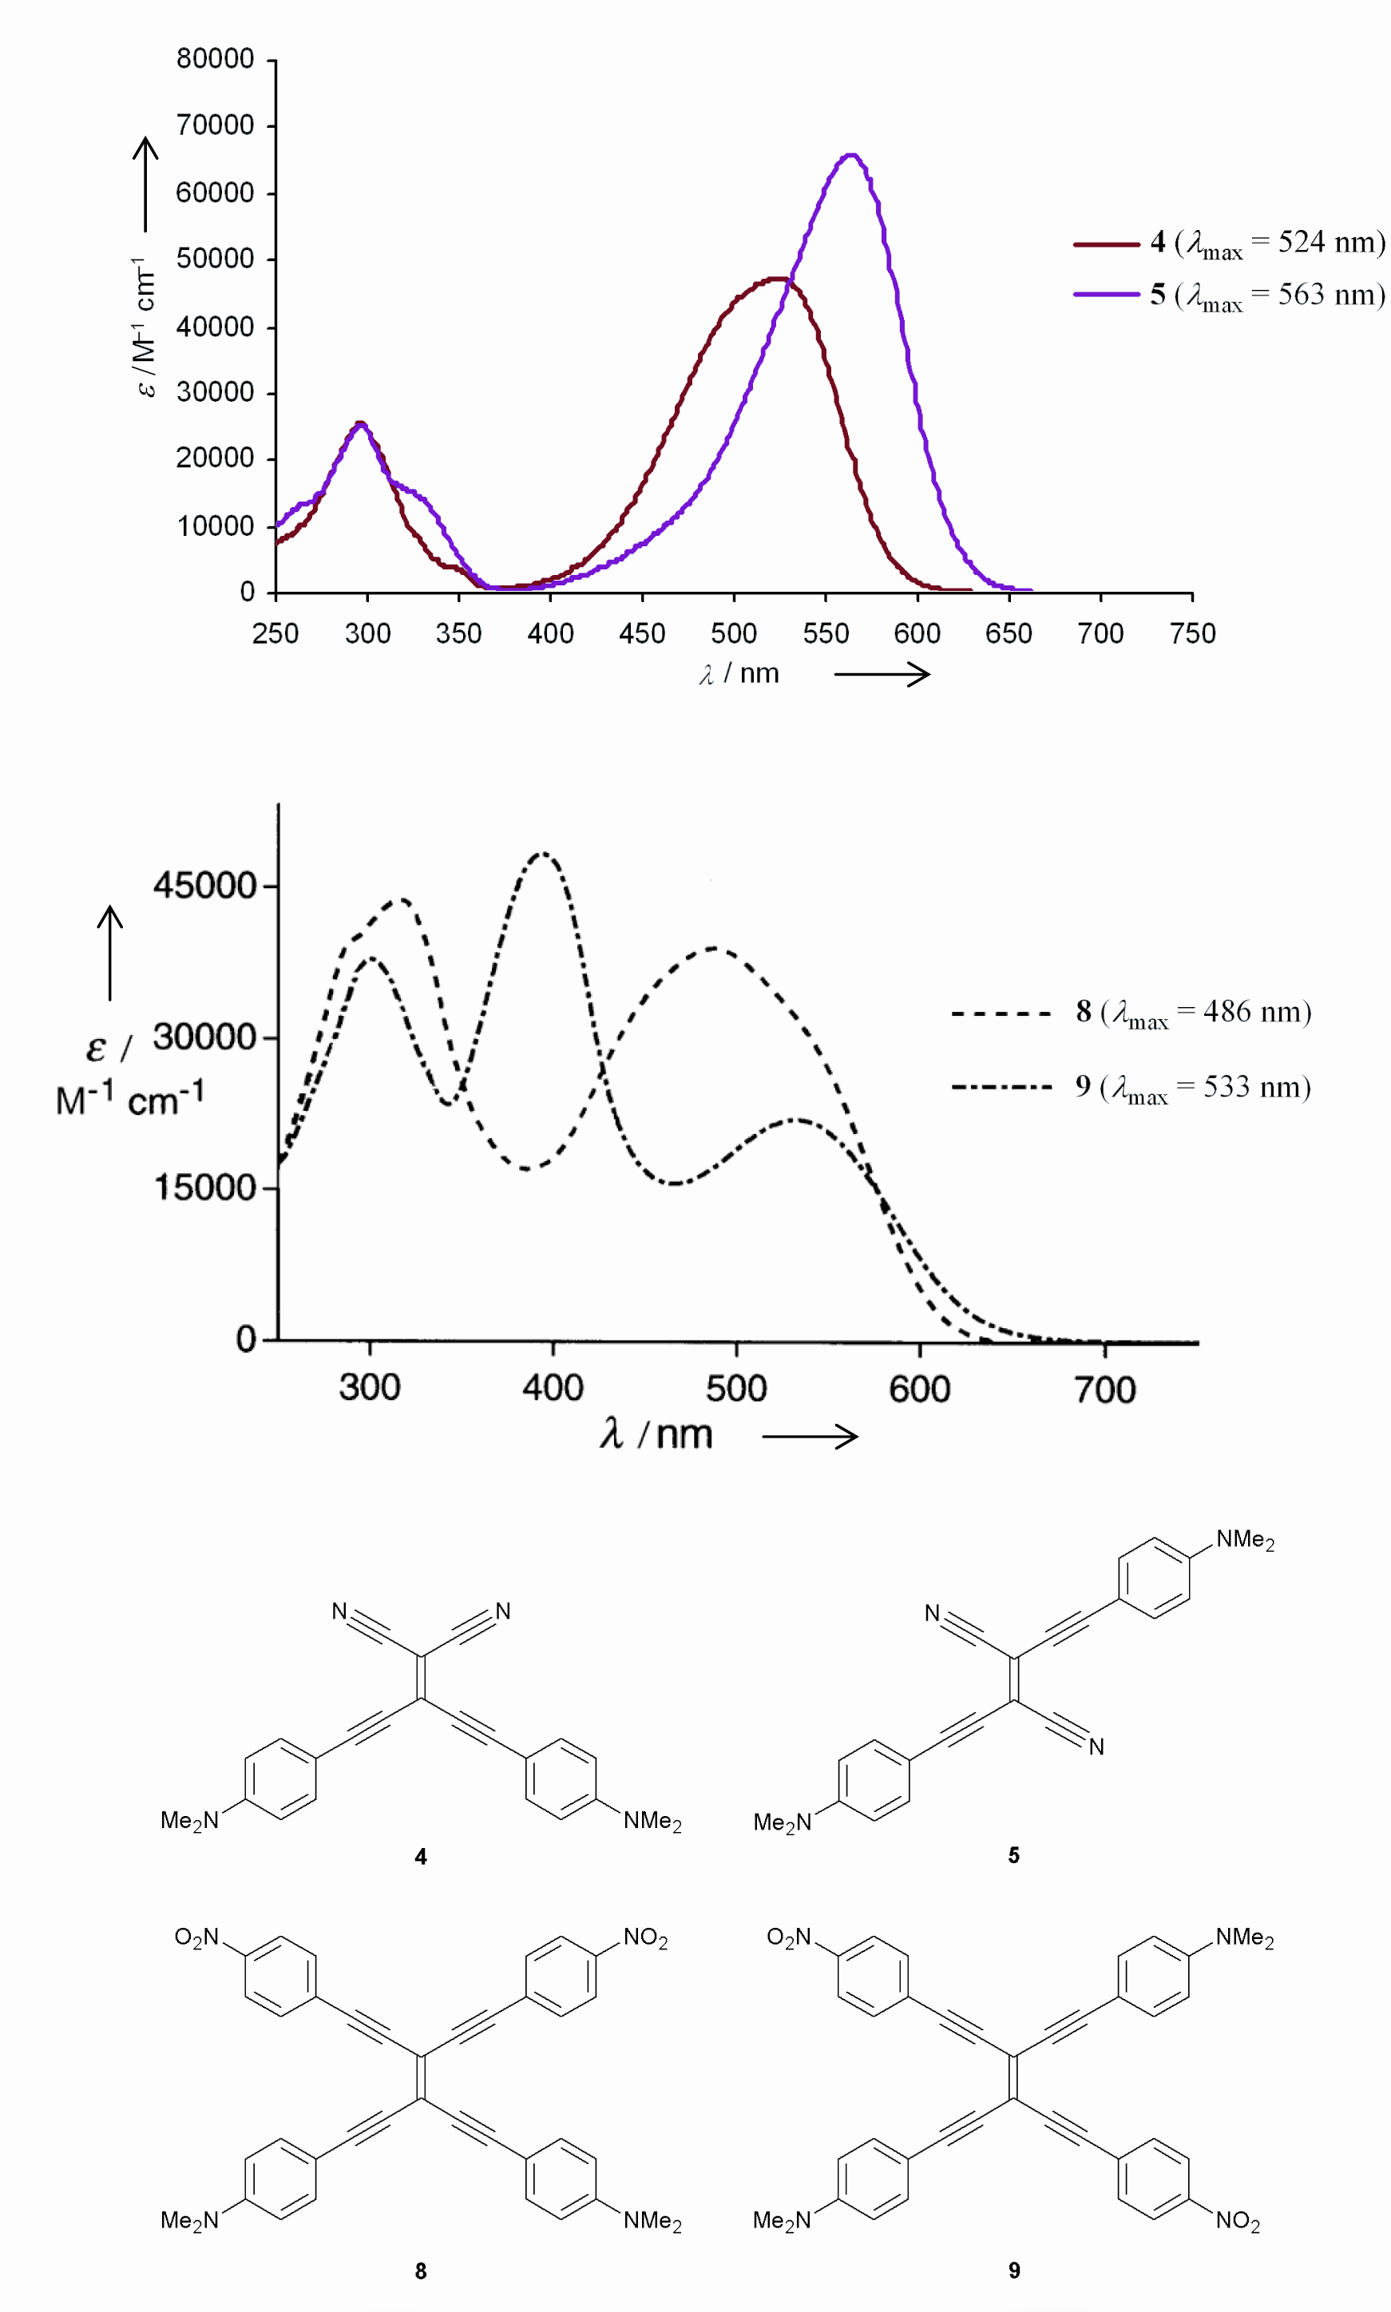
Fig. 2 UV/Vis spectra of CEEs 4 and 5 and of TEEs 8 and 9 in CHCl₃.
Electronic Supplementary Information

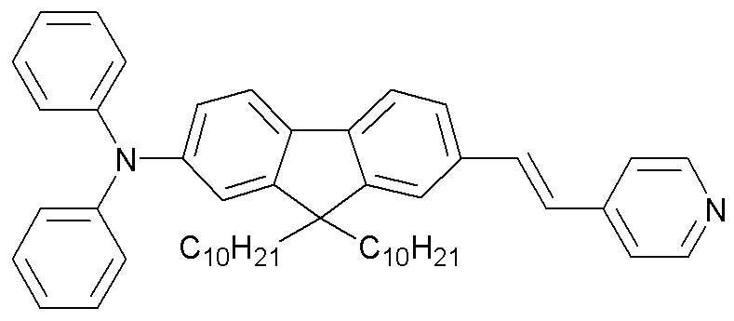
Fig. 3 Structure of the AF-50 standard.
Electronic Supplementary Information

Table 1. Cyclic voltammetry and rotating disk voltammetry data in CH₂Cl₂ (+0.1 M n-Bu₄NPF₆): potentials vs. Fc/Fc⁺. Working electrode: glassy carbon electrode; counter electrode: Pt; reference electrode: Ag/AgCl. Scan rate: 0.1 V s^{–1}

 | Cyclic Voltammetry |  |  | Rotating Disk Voltammetry
 | Eº/ Vª | ΔE_{p} /mV | E_{p} /mV^{b} | E_{1/2} /V | Slope /mV
1 | +0.56  -1.64 | 80  90 | -2.26  -2.37 | +0.59 (1 e⁻)  -1.70 (1 e⁻) | 60  70
2 | +0.56  -1.64 | 75  75 | -2.25  -2.35 | +0.59 (1 e⁻)  -1.67 (1 e⁻)  -2.39 (2 e⁻) | 70  75  150
3 | +0.67  -1.24 | 125  125 |  | +0.67 (1 e⁻)  -1.32 (1 e⁻) | 70  100
4 | -1.31 | 60 | +0.63  -2.02  -2.20 | +0.65 (2 e⁻)  -1.35 (1 e⁻)  -2.06 | 50  70  75
5 | +0.50  +0.58  -1.38 | 70  70  70 | -1.95  -2.05  -2.20 | c)  -1.44 (1 e⁻) | 100
6 | +0.79 | 65 | -0.86 | +0.79 (1 e⁻)  -0.85 (1 e⁻) | 60  60
7 | +0.69  -0.74  -0.92 | 120  60  70 | -2.25 | +0.70 (2 e⁻)  -0.77 (1 e⁻)  -0.95 (1 e⁻)  -2.31 (2 e⁻) | ^{c)}  60  60  75
ª Eº = (E_{pc} + E_{pa})/2, where E_{pc} and E_{pa} correspond to the cathodic and anodic peak potentials, respectively.
^{b} E_{p} = irreversible peak potential
^{c} Electrode inhibition during oxidation. No plateau limiting current could be observed.

